ATS Sales Outlook Plug-in Settings and Instalation

Revision Chart
A new record should be added every time a user updates this document.
Ver. # | Date | Author | Change
V.03142019 | 03/14/2019 | Prashant | Initial Draft

Table of Contents
1.0 Out Look Plug-in Settings and Instalation 2
2.0 Steps for outlook settings 4
2.1.1 Go to “View” in outlook 4
2.1.2 Click on “View Settings” 4
2.1.3 Click on “Columns…” 5
2.1.4 Click on “New Column…” 6
2.1.5 Add New Column “Name” as “CRM Sync Status”. And then Click “OK” 7
2.1.6 New Cloumn “CRM Sync Status” should be appriare as shown below. And “Maximum number of lines in Compact mode” set it to “3”. 8
2.1.7 “Move Up” “CRM Sync Status” coloumn just after “Subject”. And Click “OK”. 9
2.1.8 New column “CRM Sync Status” will be shown as below snap. 10
2.1.9 And now close the outlook and start again. 11
3.0 Un-Instalation outlook plug in 12

Out Look Plug-in Settings and Instalation
CRMApp.OutlookAddin.vsto outlook plug-in need to be install on window user system.

Steps
1. Copy “C:\Software\CRM\CRMApp.OutlookAddin.vsto” and and paste into Run (Window+R). And Click “OK”.

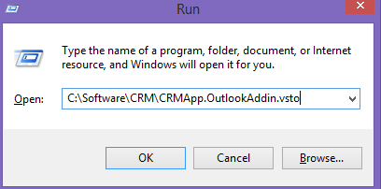

2. On popup click on “Install”.
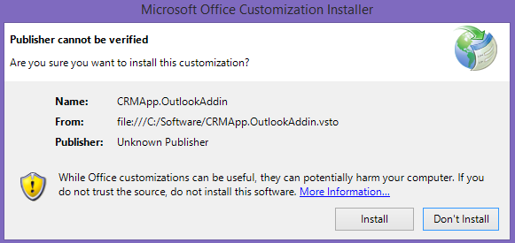

3. And below screen confirmed the installation. So now close the popup.
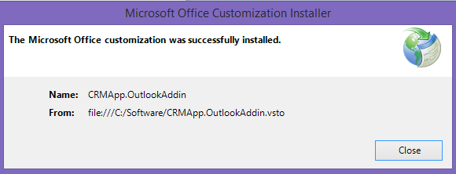

Steps for outlook settings

Go to “View” in outlook

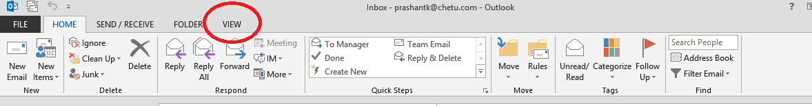

Click on “View Settings”
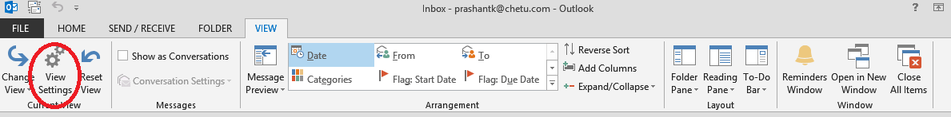

Click on “Columns…”
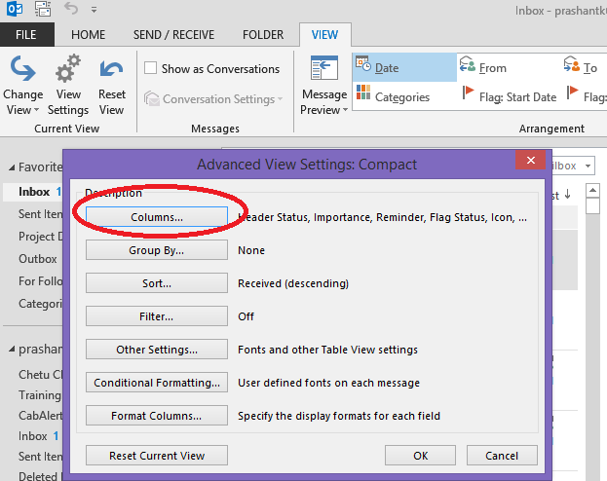

Click on “New Column…”
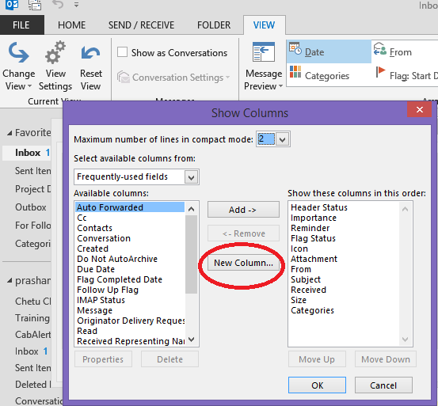

Add New Column “Name” as “CRM Sync Status”. And then Click “OK”

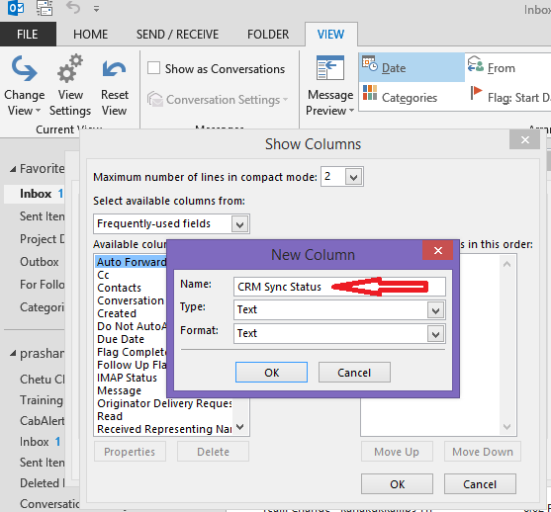

New Cloumn “ATS Sync Status” should be appriare as shown below. And “Maximum number of lines in Compact mode” set it to “3”.

“Move Up” “ATS Sync Status” coloumn just after “Subject”. And Click “OK”.
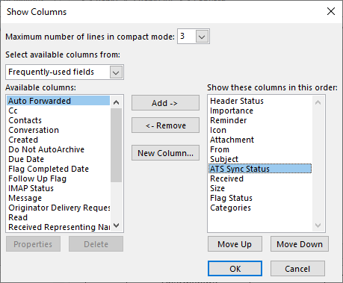

New column “ATS Sync Status” will be shown as below snap.
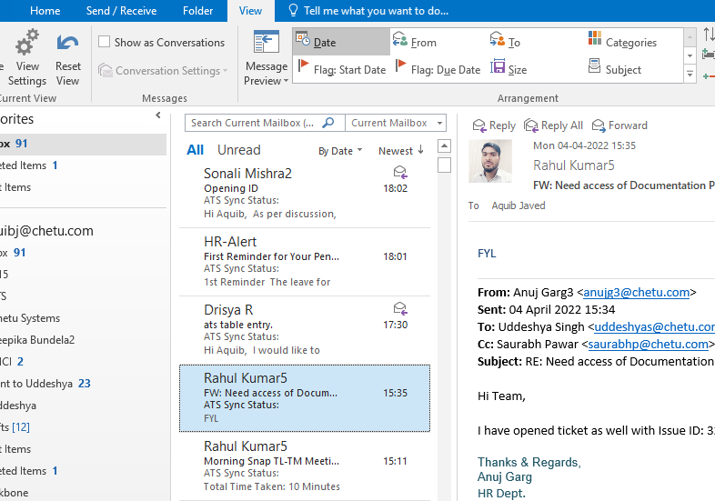

And now close the outlook and start again.
You can see plug-in menu and start using them as in below snap.

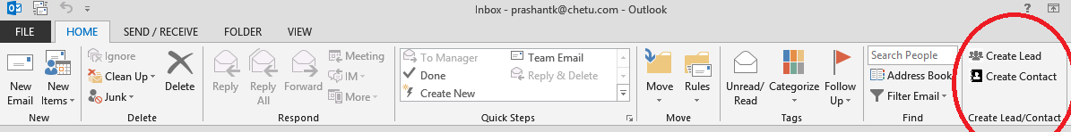

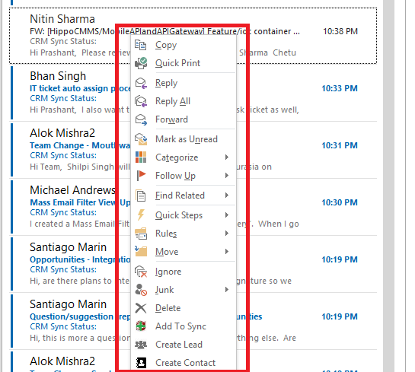

Un-Instalation outlook plug in
- Serch for Add or Remove

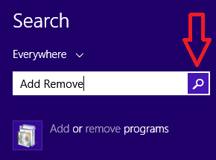

- Un-install “CRMApp.OutlookAddin”

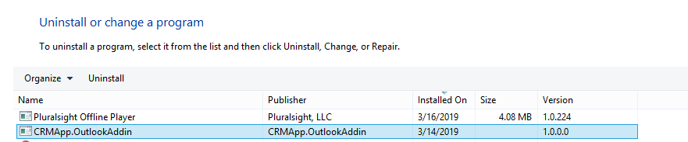

- And also remove outlook plug-in Chase folder from
“C:\Users\user\AppData\Local\Apps” replace user to your user name like “prashantk”. So you your path will be like as given below

“C:\Users\prashantk\AppData\Local\Apps”. Copy path and then

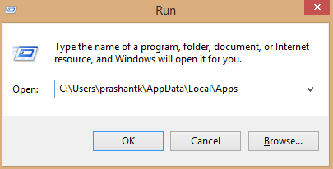
Click “OK” and remove 2.0 folder.

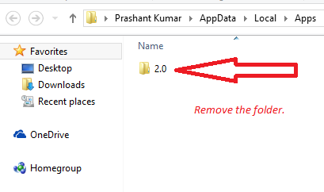

- Now un-instalation complete. And you can install plug-in. Please follow steps as define in document.

